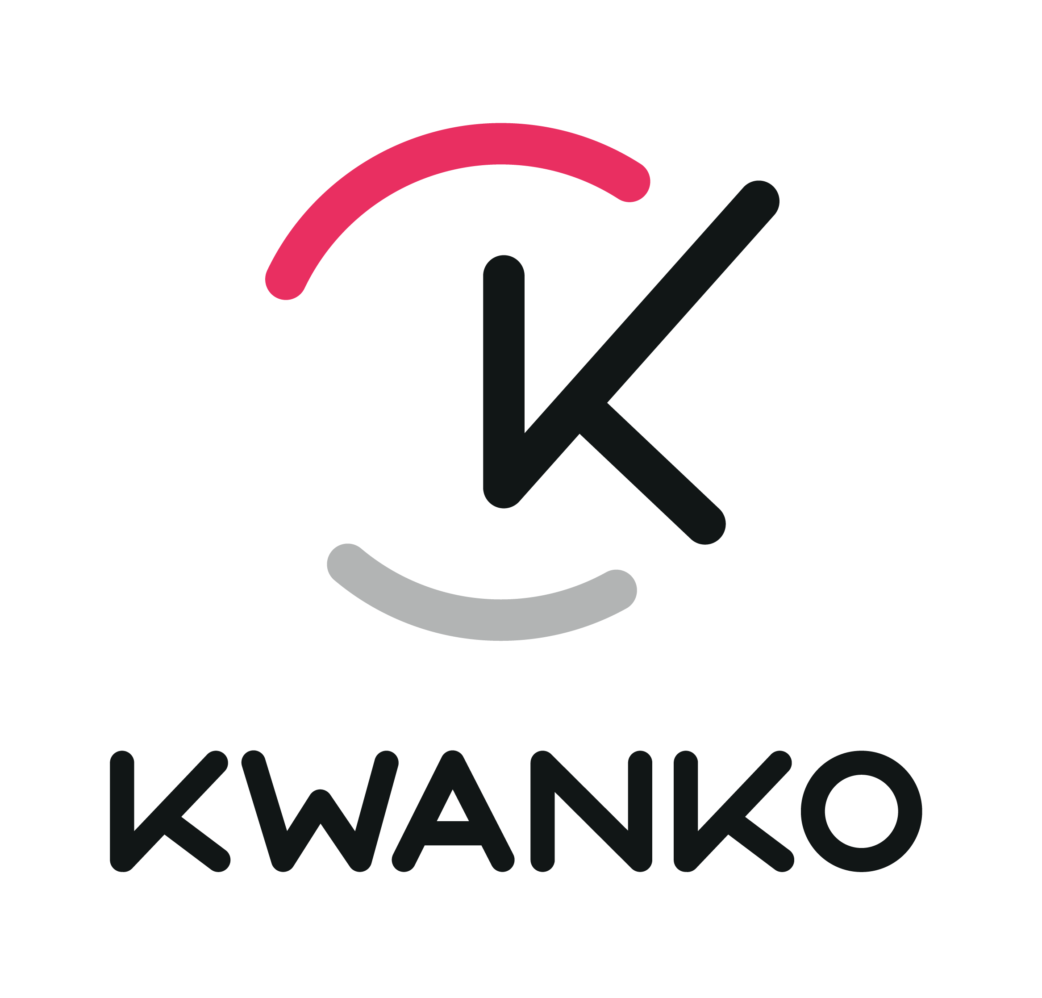
KWANKO E-MAIL MARKETING
TERMS AND CONDITIONS

KWANKO SA is a joint-stock company with a capital of 78,456.46 euro, with its registered office located at 60 Boulevard du Maréchal Joffre - 92340 Bourg-La-Reine, registered in the Trade and Companies Register of NANTERRE under the number 440 546 885, and represented by Mr François BIEBER acting in his capacity as Chief Executive Officer, hereinafter referred to as “Kwanko”;

wishes to submit to the company,

Company name with its registrated office located on HQ address, registered in Trade and Companies Register of city of registration under number registration number, and represented by legal representative name acting as position, hereinafter referred to as the “Publisher”;

the following Terms and Conditions that the Publisher will have to comply with as part of any relationship that may be established between both parties.

Specifically, by signing this acceptance letter, the Publisher warrants to Kwanko to comply with the terms and conditions listed here below while performing the activities envisaged by the relationship that may be established with Kwanko (“Relationship”).

- The Publisher agrees to distribute through its publishing network, in order to perform the obligations arising from the Relationship, the advertising material owned by Kwanko’s (“Advertisers”), provided by Kwanko (hereinafter referred to as “Advertising Material”), only and exclusively through websites/databases owned by the Publisher and properly approved by the Kwanko team.

- The Publisher owns or manages as a concession holder one or more databases and declares how they have been collected. Please fill in the name of each database and website in the annex below.

- In the light of the above and in case of need, the Publisher agrees to provide, upon simple request, proof of given consent by indicating the date, time and IP address pertaining to the issuing of given consent.
The Publisher agrees that for every Kwanko campaign he accepts the following policy about Content and Sending:

- E-mails may only be sent on behalf of the database owner's name, not on behalf of third parties.
- E-mails can’t contain promotion from parties of which the permission isn’t in these Terms.
- Only a clear sender, company name and related content information is allowed.
- E-mails always need to include a response possibility, a "noreply@" or similar e-mail address is therefore not allowed.
- A recipient must always be able to unsubscribe from the e-mailing without any costs.
- An unsubscribe-request needs to be processed as soon as possible.
- The layout of the e-mail needs to match the style of the sender. It has to be clear that the e-mail originates from this specific sender and that the whole promotion is the message.
- The e-mail needs to explain where and how the recipient approved the e-mail.

- For e-mail marketing campaigns the Publisher in the person of its legal representative name of legal representative hereby declares that all the e-mail addresses used in order to send advertising material of all campaigns run by Kwanko, have been collected with specific consent of the users so that advertising material of third parties may be sent to their given e-mail addresses. The Publisher also declares that all e-mail addresses collected from May 25th will have to be compliance with the GDPR, GENERAL DATA PROTECTION REGULATION (EU) 2016/679 OF THE EUROPEAN PARLIAMENT AND OF THE COUNCIL of 27 April 2016. It is understood that the advertising material provided by Kwanko will be sent directly by the Publisher as Kwanko doesn’t have knowledge of the names and e-mail addresses of the individuals to whom the communication will be sent, the Publisher acting as Data Controller.

- In case of default of the obligations undertaken with these Terms & Conditions, and in the light of the above, the legal representative hereby undertakes to indemnify and hold Kwanko harmless from any and all responsibility, damages and expenses in connection with any lawsuits, claims and compensations, including by third parties, associated with or in any event deriving from the falseness and unlawfulness of the information provided above.

- In case of conflict between these Terms & Conditions and other agreements in existence between the two companies, the contents of these Terms shall prevail.
These Terms are governed by the French law. Any controversy pertaining to or arising from these Terms shall be submitted to the exclusive jurisdiction of the Court of Nanterre.

Please complete the annex before signing these Terms and Conditions.

For the Publisher

Name:

Position:

Date:

Signature:

For Kwanko

Name:

Position:

Date:

Signature:

Annex: additional information

- Name and contact of the Data Protection Officer (if any): ___________________________
- Categories of processed personal data: (list)_______________________________________
- Purpose of processed personal data: (list)__________________________________________
- Please provide a link to your Privacy Policy, or join them in annex: _________________
- Please fill in the following table with, for each database name, the url on which you collect the consent and an example of the consent collection phrase/text.
Database name | Website url | Consent collection phrase/text

